May 27th, 2012
Hi
Well, first will be congratulations to Tom for his graduation. Well done! I had no idea you were graduating this year. Also, I have had to work out what degree you got, as I know you have been studying for both a PhD and an MD. But it must be the PhD and not the MD as the colour of the crows-foot emblem of the gown is different from that on Leonie's gown (in one of the photos sent). I went online to check on academic regalia at Harvard, and while I did not find a medical school gown, I did find another PhD gown. Now, I have to know whether or not you have finished your MD. The photographs you sent were very interesting. And I liked those with Kaia - she seems to be a very lively girl. I particularly liked the one of her up on the dais - did she run up spontaneously or did she go up with Tom? A pity many of the pics of her up there are blurred, but I guess they had to be taken quickly. [I also assume that if Tom now has both degrees and will no longer be at HMS, his e-mail address will have to change.]
Here in HK, there was an eclipse of the sun early last Monday morning, though it was only visible from three locations and was mainly hidden by cloud. I did not see it, so I will have to wait for the next one, which unfortunately will not be for 300 years.
I got a call from dermatologist to say that both results for the biopsies turned out to be sBCC positive. The excision on the neck was large enough to have removed all the offending tissue ( I always encourage them to do larger excisions precisely for that reason as it saves having to have further operations). The excision at the top of the nose did not remove everything, so the folks at the hospital may (just may) later remove that. I have a regular hospital appointment in July (first for well over a year: I kept postponing it due to not having had any biopsies at the dermatology clinic and hence nothing to report). I went to the clinic on Thursday to have the stitches removed. They could not find any on the nose; these could either have fallen out or have been absorbed though as there is only hard tissue on the nose, the former is more likely. Also at the clinic was a prisoner with two guards. He was not young and looked miserable with his hands handcuffed; quite sad really.
Talking about medical things, there is an article in the latest Time magazine talking about changing views regarding screening for cancer. The website below is about prostate cancer. It also comments that views have changed as to the advisability of early screening for breast cancer (~40) and the apparent lack of usefulness of X-ray screening for lung cancer in helping patients live longer (though one needs to read the paper edition of the magazine for the details).
http://www.time.com/time/subscriber/article/0,33009,2115629,00.html
This past week, I went for a swim on five days. The water in the pool here is cooler than that in the hotel pool. It is taking a bit of getting used to swimming 50 m lengths again. Having been doing ~30 m lengths in the hotel pool for so long, 50 m seems very long.
I am still very busy on the revision of the science books for Singapore. Nearly all the work is on the junior secondary science books (maybe about 95% of the work); the review committee is extremely picky and often very pedantic and demanding in what they want included or excluded! The O-level chemistry books, reviewed by a different team, are not a problem and the team is also amenable to reason when the editors make comments or suggestions to them; much more so than the junior secondary science group.
Yesterday, I again cleaned the flat - groan - the first time for two weeks. Still, it took only about 45 minutes this time. Not very dirty at all. Swept the floor first with the hand-brush and collected very little dust. Then washed the floor, using just one bowl of water which was not very dirty on finishing. I guess the flat would be even cleaner if I did not open any windows. So, will clean it again in another two weeks. Washing also needs to be done now that I am no longer in the hotel. I have not used the washing machine yet; just use the bath, and with cold water at that.
That seems to be it for now.
Cheers

May 29th, 2011
Hi
Not much to write about. The aircraft carrier USS Carl Vinson arrived in HK last Sunday. The captain, inevitably, was quizzed on its role in the burying of bin Laden, but he was saying nothing. Also, last Sunday, South Africa won the London 7s. Fiji beat NZ in the semi-finals but that was not enough to stop NZ clinching the overall title, their 9th in 12 years. This weekend, the last round of the 7s is being held in Edinburgh but the fight is between Fiji and England for the overall second place.
In HK, the government is in trouble again. This time it is for (alleged) interference in the selection of a group to offer computer services to children. Although the selection process was supposed to be independent, someone high up in the government told the group doing the selection to choose the pro-government / pro-Beijing tender, even though it was not the best. It is said that the order came from someone higher than the Financial Secretary (FS), which means it was either the Chief Executive himself or his deputy, as these are the only people higher than the FS.
Very high levels of air pollution again in HK. Right now, the index in parts of HK Island has reached 190 which is a dangerous level.
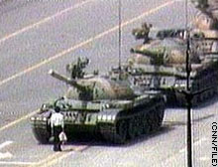
Next Saturday is the anniversary of the June 4th 1989 massacre in Beijing. There will be the annual candlelight vigil in HK, which is the only city in China to commemorate the event.
The material below was in last year's letter. But as it may still be interesting, I will leave them in.
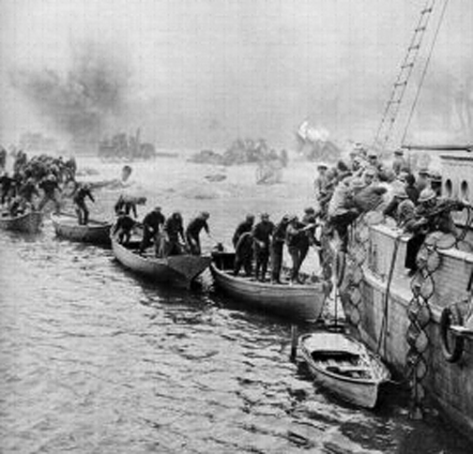
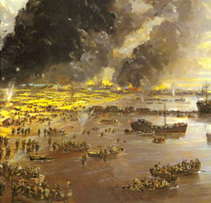
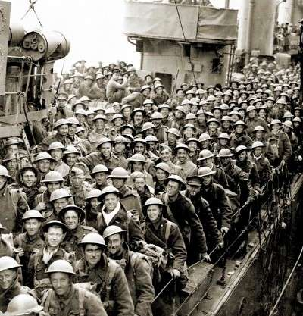
Some interesting news items from the past week. First, research in the UK suggests that brushing teeth less than twice a day increases the risk of heart attacks and strokes. Something to do with bacteria from the mouth getting into the blood and somehow causing damage elsewhere. Then there was the 70th anniversary of the Dunkirk evacuation in 1940 when lots of little boats sailed from England across the channel to France to rescue about 340 000 troops stranded on the beaches who had been driven back to the sea in France by the Germans, and ferried them to larger vessels off-shore. I suppose you know the story. To commemorate the rescue, many of the actual boats that helped in the rescue sailed across to France again. It was after this rescue that Churchill gave his famous defiant speech “We shall fight on the beaches ….” If you want to listen to it, go to this website:
http://news.bbc.co.uk/onthisday/hi/dates/stories/june/4/newsid_3500000/3500865.stm
Or, more directly:
http://www.bbc.co.uk/mediaselector/check/player/nol/newsid_6570000/newsid_6571500?redirect=6571515.stm&bbwm=1&bbram=1&nbwm=1&nbram=1&news=1
Another health issue I learnt about this past week regards sunscreens. It turns out that many of them not only provide little protection but may increase the risk of cancers. All the sunscreens available in the US have been evaluated and of the 500 sports/sunbathing sunscreens, only 39 (~8%) are regarded as safe. Similar products in Europe are a little better as they are allowed to include chemicals that are not yet in use in the US. Look at the websites below. The second website lists every sunscreen on the market with details about them.
http://www.aolnews.com/health/article/study-many-sunscreens-may-be-accelerating-cancer/19488158
http://www.ewg.org/2010sunscreen/best-beach-sport-sunscreens/
That seems to be it for now.
Cheers

